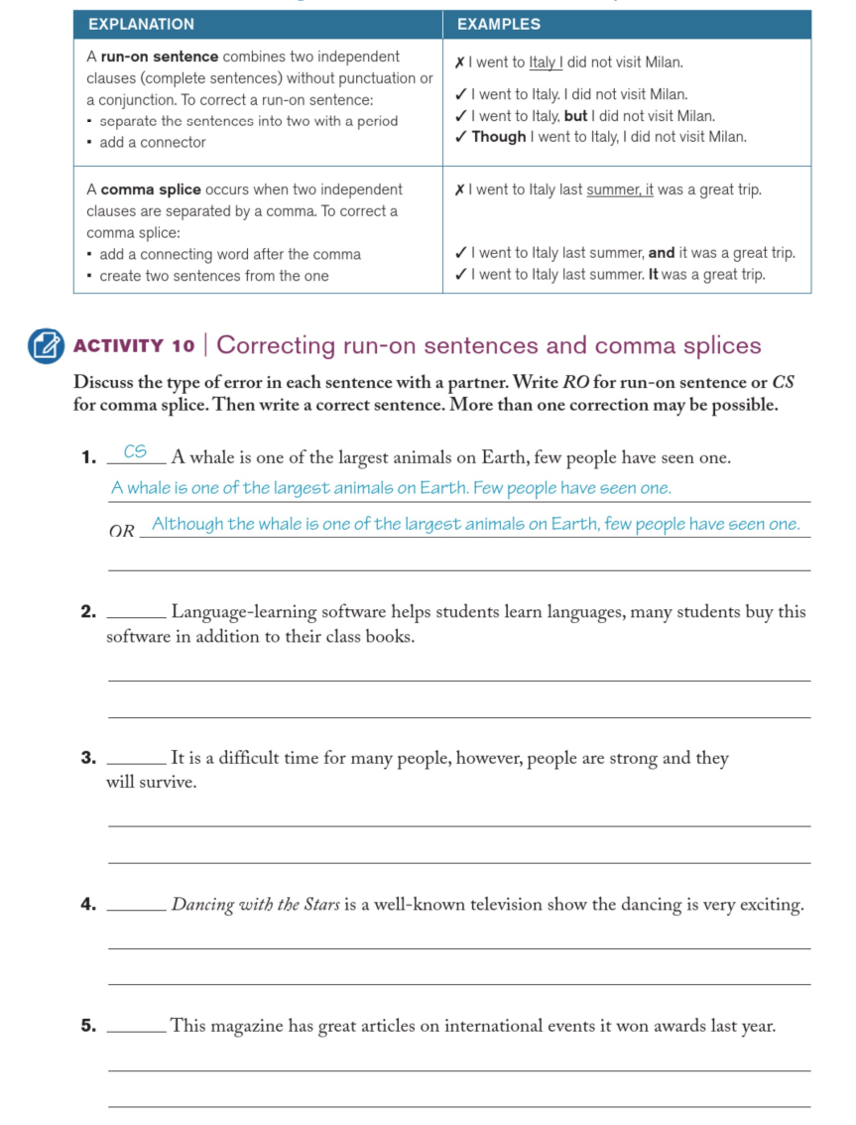
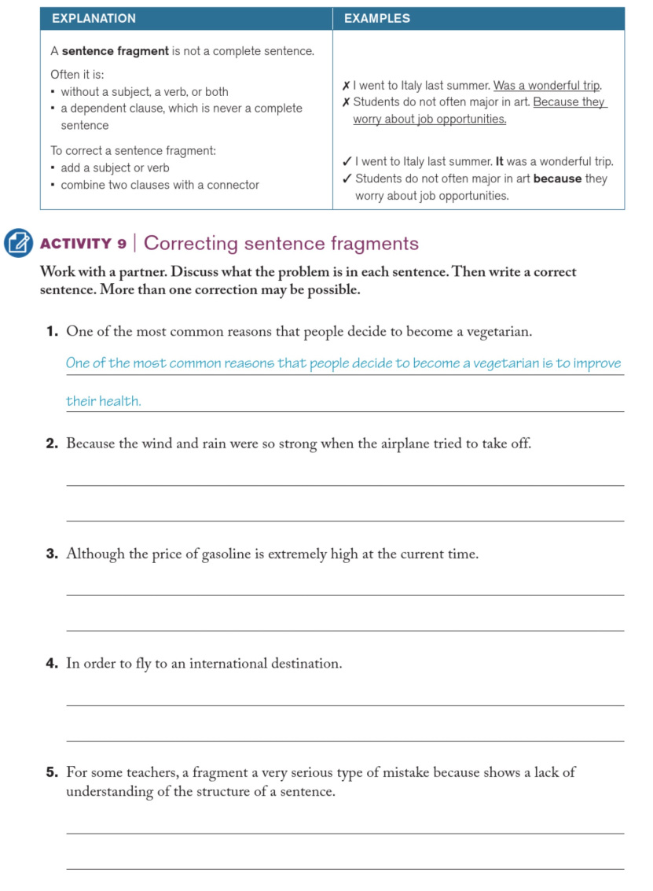

TEMPLATE FOR AN OPINION PARAGRAPH
In my opinion, ____________________________ (state your main idea clearly). I believe this because of several reasons.
First of all, ____________________________ (give your first reason). This is true since ____________________________ (give a supporting fact).
Secondly, ____________________________ (give your second reason). For example, ____________________________ (give supporting example).
Another important reason is that ____________________________ (give third reason if needed). To further explain, ____________________________ (give further explanation).
In conclusion, I strongly think that ____________________________ (repeat your opinion using different words). All the reasons above clearly show that ____________________________ (give a recommendation of action).

